P234 第2题

#include<iostream>

using namespace std;

class student

{

public:

void input(student&stu);

void output(student&stu);

private:

char name[20] = { "\0" };

unsigned int id = 0;

double score = 0;

};

void student::input(student&stu)

{

cout << "name?";

cin >> stu.name;

cout << "id?";

cin >> stu.id;

cout << "score?";

cin >> stu.score;

}

void student::output(student&stu)

{

cout << "name" << stu.name << "\tid:" << stu.id << "\tscore:" << stu.score << endl;

}

int main()

{

student s;

s.input(s);

s.output(s);

}

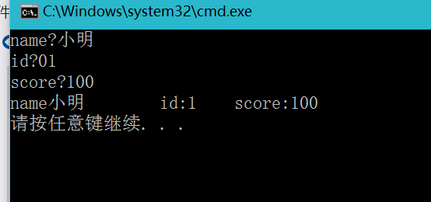

P242 第1题

#include<iostream>

using namespace std;

int number = 10;

class Book

{

public:

Book(char\*, int, int);

void display()

{

cout << "bookname:" << bookname << "\tprice:" << price << "\tnumber:" << number << endl;

}

void borrow()

{

if (number) {

number--;

cout << "当前图书数量：" << number << endl;

}

else cout << "此书已经没有存数：" << endl;

}

void restore()

{

number++;

cout << "当前图书数量：" << number << endl;

}

char \*bookname;

int price;

int number;

};

Book::Book(char\*p, int x, int y)

{

bookname = new char[20];

bookname = p;

price = x;

number = y;

}

int main()

{

int i = 0;

char sp[] = { "深夜食堂" };

char\*s = sp;

Book k(s, 25, 4);

while (1)

{

cout << "显示图书情况--1，借阅书本请按--2，归还书本请按--3" << endl;

cin >> i;

switch (i)

{

case 1:k.display(); break;

case 2:k.borrow();break;

case 3:k.restore();break;

}

}

}

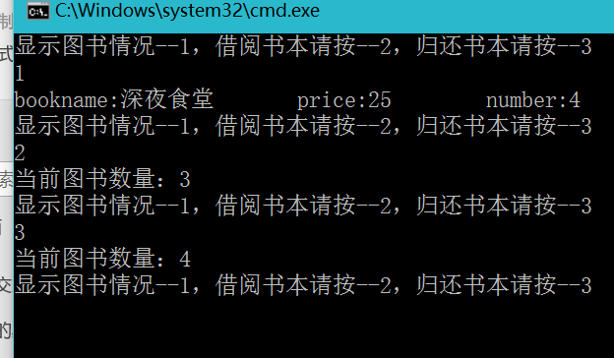

P242 第3题

#include<iostream>

using namespace std;

class student

{

public:

void scoretotalcount(double s);

double sum();

double average();

private:

static double total;

static int count;

};

double student::total = 0;

int student::count = 0;

int main()

{

student class3;

char Switch = 'n';

int temp;

while (Switch == 'n')

{

cout << "请输入学生成绩：";

cin >> temp;

class3.scoretotalcount(temp);

cout << " "<<"继续输入（n）终止操作（m）";

cin >> Switch;

}

cout << "总分：" << class3.sum() << endl;

cout << "平均分：" << class3.average() << endl;

}

void student::scoretotalcount(double s)

{

count++;

total += s;

}

double student::sum()

{

return total;

}

double student::average()

{

return total / (double)(count);

}

